*The Village*

A

**Project Report On**

**The Village System**



Submitted to

**Department of Computer Engineering**

**Cusrow Wadia Institute of Technology,**

**Pune-411001**

By:-

1.Saurabh Prakash Nale

2.Aishwarya Narender Singh

3.Rohan Suresh Bedage

*CWIT, PUNE -1* *DEPT OF COMPUTER ENGG.*



*The Village*

A

Project Report On

The Village System

Under the Guidance of

Prof. R. P. Shete

Submitted by

1.Saurabh Prakash Nale

2.Aishwarya Narender Singh

3.Rohan Suresh Bedage

Department of Computer Engineering

Cusrow Wadia Institute of Technology

Pune-411001

(2020-2021)

*CWIT, PUNE -1* *DEPT OF COMPUTER ENGG.*



*The Village*

**CERTIFICATE**



This is to certify that the below mentioned third year Diploma students have carried out the

necessary project work on "The Village System" in department of Computer Engineering, Cusrow Wadia Institute of Technology, Pune-1.They have completed this project work under my guidance in satisfactory manner in May 2021 of third year Diploma.

1. Saurabh Prakash Nale
2. Aishwarya Narender Singh
3. Rohan Suresh Bedage

Computer Engineering students have successfully completed project on “The Village

System “ towards the fulfilment of their Diploma in Computer Engineering in the academic

year 2020-20201. The performance of each of these students during the course was good.

Date:

|  |  |  |
| --- | --- | --- |
| Prof. R.P.Shete | Prof. A. A. Jambhale | Prof. V. R. Rao |
| Guide | H.O.D Computer Dept. | Principle |
|  |  |  |

*CWIT, PUNE -1* *DEPT OF COMPUTER ENGG.*



*The Village*

**ACKNOWLEDGEMENT**

We have a great pleasure in presenting this project report on “The Village System” and to express our deep regards towards those who have offered their valuable time and guidance in our hour of need because when any work is to be successfully completed it should be supported and guided by proper persons. For completing this project we really got inspiration and guidance from many people.

We would like to express our sincere and whole hearted thanks to guide Prof.R.P.Shete ,Prof.K.Jakotiya without their support it was unable to express our ideas in this project . We also thank Mr. Jambhale , Head of Department for his support and encouragement.

We are also glad to express our gratitude and thanks to parents and friends who directly or indirectly supported the completion of this project.

|  |  |
| --- | --- |
| Saurabh Prakash Nale | 194086 |
| Aishwarya Narender Singh | 194088 |
| Rohan Suresh Bedage | 194093 |

*CWIT, PUNE -1* *DEPT OF COMPUTER ENGG.*



*The Village*

**ABSTRACT**

*This project deals with the study and development of the village as a Digital/Smart village. We define digital village as a bundle of services which are delivered to its residents and businesses in an effective and efficient manner. The basic concept of digital village is to collect community efforts and strength of people from various streams and integrate it with information technology to provide benefits to the rural community.*

*It also makes the village self-sufficient in respect of their needs and focuses on improved resource use efficiency, local self-governance, access to assure basic amenities and responsible individual and community behaviour to build a happy society. We are making digital village by taking smart decisions using smart technologies and services*

*CWIT, PUNE -1* *DEPT OF COMPUTER ENGG.*



*The Village*

**TABLE OF CONTENTS**

|  |  |  |  |
| --- | --- | --- | --- |
| **Sr. No** |  | **Contents** | **Page No.** |
|  |  | |  |
| 1 | Introduction | | 1 |
| 2 | Presently Available System | | 2 |
| 3 | Need of Such System | | 3 |
| 4 | Detailed Problem Statement | | 4 |
| 5 | Software and Hardware Requirements | | 5 |
|  |  |  |  |
|  | 5.1 | Software Requirements |  |
|  | 5.2 | Hardware Requirements |  |
|  |  | |  |
| 6 | System Design | | 6 |
|  | 6.1 | Use Case Diagrams |  |
|  | 6.2 | Data Flow Diagrams |  |
| 7 | Salient Features | | 9 |
| 8 | Application Preview | | 10 |
| 9 | Future Prospect | | 26 |
| 10 | References | | 27 |

*CWIT, PUNE -1* *DEPT OF COMPUTER ENGG.*



*The Village*

1. **Introduction:**

Village is the main criteria for the development of a nation, so develop the village in such a way that is self-dependent in providing the services, employment & well connected to the rest of the world & new technology that is DIGITAL VILLAGE. The digital village provides facilities for sustainable family relationships without disturbing the lifestyle of different generations. So, it is necessary to design and develop a digital village with urbanization and modernization. People migrate from one place to another for different facilities such as education, employment, and affinity of people towards the city. Digital village is that modern energy access can act as a catalyst of development in education, health, clean water, sanitation, and environmental sustainability.

Development of a nation at any phase is linked with technology and when it happens there is advancement in science and innovation. Now-a-days our government also gives strong focus on digital villages. So, our project is also a small step towards making India a developed nation to the progress of village and smarten the rural development using ICT (Information and communication technology) solution to achieve self-sustainability.

Digital Village and would become the focal point for providing information, social, e-learning and e-governance services to villages. This can become the springboard for rapid economic growth in the rural areas.

*CWIT,PUNE-1* *1* *DEPT OF COMPUTER ENGG*



*The Village*

**2. Presently Available System:**

This kind of system is not presently available. It's our own idea to build a system for the people of the village for helping the people as well as the Gram Panchayat. This system will provide various facilities for which villagers have to do it manually. But by the creation of this system the work will be semi - automatic and not will be hectic.

This system will provide villagers the facility of online payment of bills like Water tax and Property tax, it will also provide medical information, it will have 24*7 help desk for the villagers if they have any query or issue and so on. In so many ways our system will be helpful for the villagers and for the Gram Panchayat.

*CWIT,PUNE-1* *2* *DEPT OF COMPUTER ENGG*



*The Village*

**3. Need of Such System:**

At present, one of the major challenges in India is growing population and rapid urbanization. This urban growth to certain expansion is unavoidable, as the economic pursuits and aspirations of the population do change and expand. This needs to be inverted and suitably managed through a balance between rural and urban quality of life through the system.

A “Digital Village” will furnish long-term social and economic welfare action for village communities which will empower and enhance involvement in local governance processes, encourage entrepreneurship and build more lively communities.

At the same time, a “Digital Village” will ensure good facilities, payment facility, notifications alerts, job facility, help desk facility, medical online facility, government schemes, chat bot facility, online post box status, online documentation download facility, etc.

*CWIT,PUNE-1* *3* *DEPT OF COMPUTER ENGG*



*The Village*

**4.Detailed Problem Statement:**

The Village System is very useful to villagers/users. The aim of this project is to provide a quick, immediate and easy way to help villagers. It can provide special advantages to villagers. Providing the information regarding various government schemes, news related to the village. Pre-notification of the occurrence of the event to the villagers (For ex. Power-cut of electricity, etc.). Advertising the Tourists attraction places, as in return it will help development of villagers economically. A digital village is not only bringing Internet connection to the rural lands, but will also provide support to the Gram Panchayat and villagers.

*CWIT,PUNE-1* *4* *DEPT OF COMPUTER ENGG*



*The Village*

**5. Software and Hardware Requirements:**

**5.1 Software Requirements :**

* Operating System : Windows 8/10
* Web Browser : Google/Mozilla
* Application Server : XAMPP
* Database : Excel sheet/MySQL Database

**5.2 Hardware Requirements :**

* Processor : Intel i3 4th Generation or Above
* Speed : 2.3 GHz or Above
* RAM : 4 GB minimum
* Hard Drive : 1 TB

*CWIT,PUNE-1* *5* *DEPT OF COMPUTER ENGG*



*The Village*

**6.System Design :**

**6.1 Use Case Diagram**



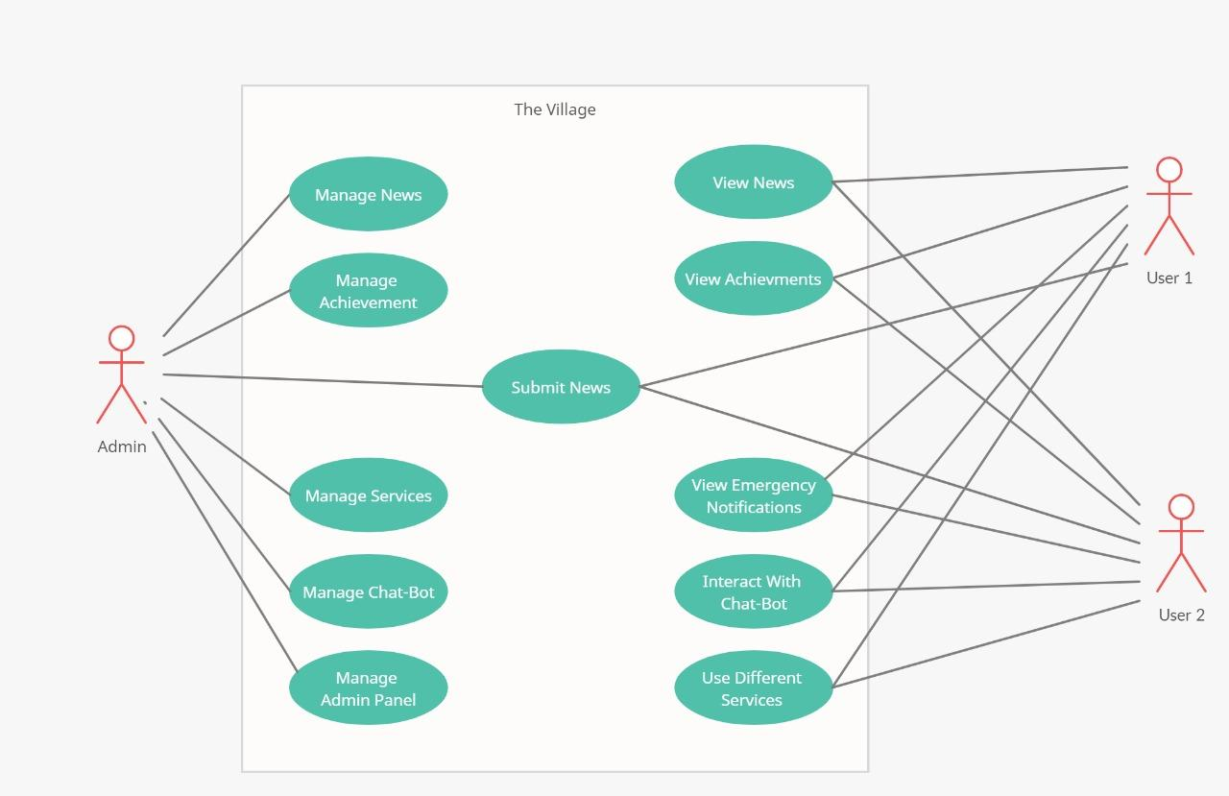

\

*CWIT,PUNE-1* *6* *DEPT OF COMPUTER ENGG*



*The Village*

**6.2 DFD Diagrams:**

**DFD DIAGRAM - LEVEL 0**

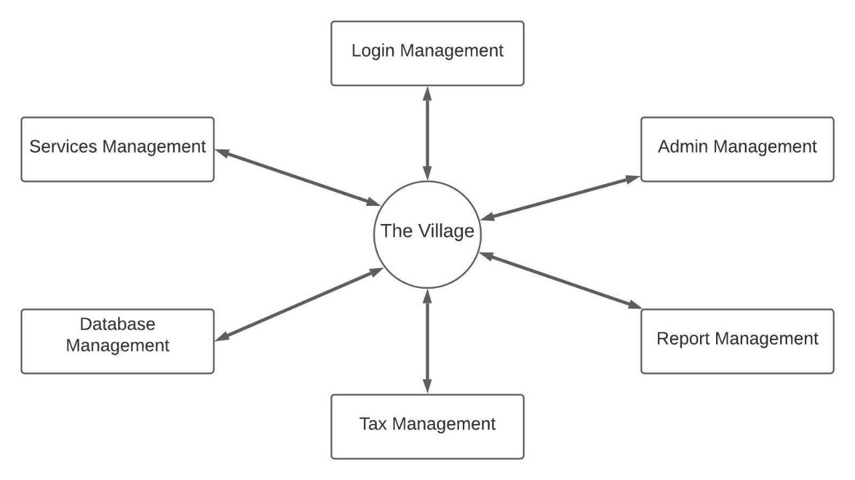

**DFD DIAGRAM – LEVEL 1**

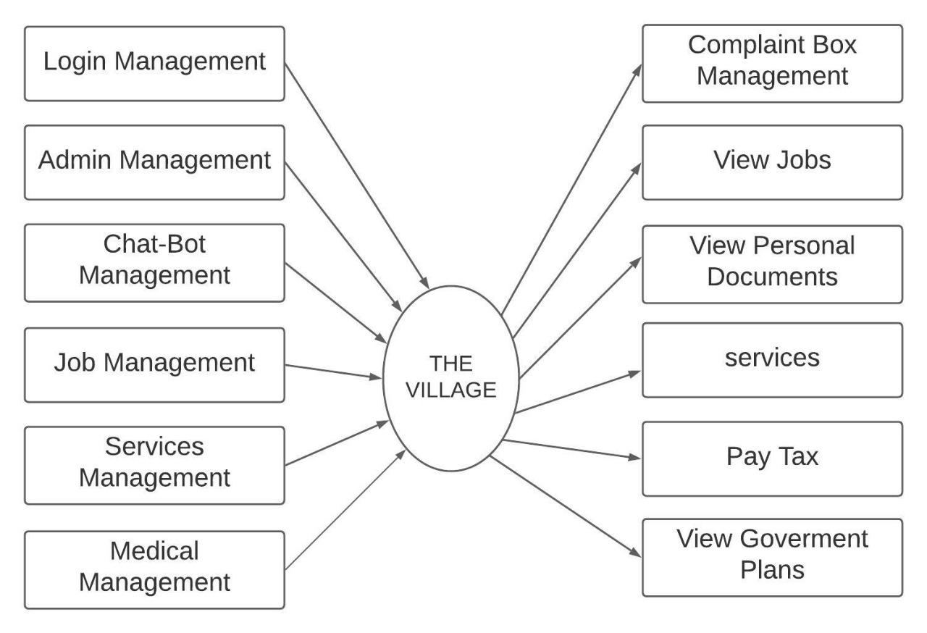

*CWIT,PUNE-1* *7* *DEPT OF COMPUTER ENGG*



*The Village*

**DFD DIAGRAM LEVEL 2**

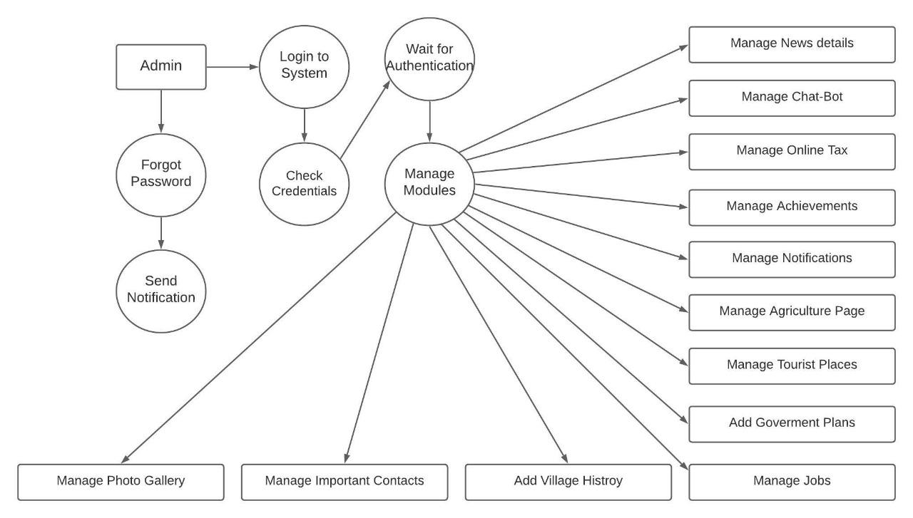

*CWIT,PUNE-1* *8* *DEPT OF COMPUTER ENGG*



*The Village*

**7.Salient Features**

The features of Village System include:-

1. Modern, easy to use interface
2. Personalised Dashboard
3. Pay Online Taxes
4. Convenient file management
5. Simple and intuitive text editor
6. Notifications
7. Job Selection
8. Customisable site design and layout
9. Mass enrolment
10. Supports open standards
11. Post Box system
12. Manage user roles and permissions
13. High interoperability

*CWIT,PUNE-1* *9* *DEPT OF COMPUTER ENGG*



*The Village*

**8.Application Preview :**



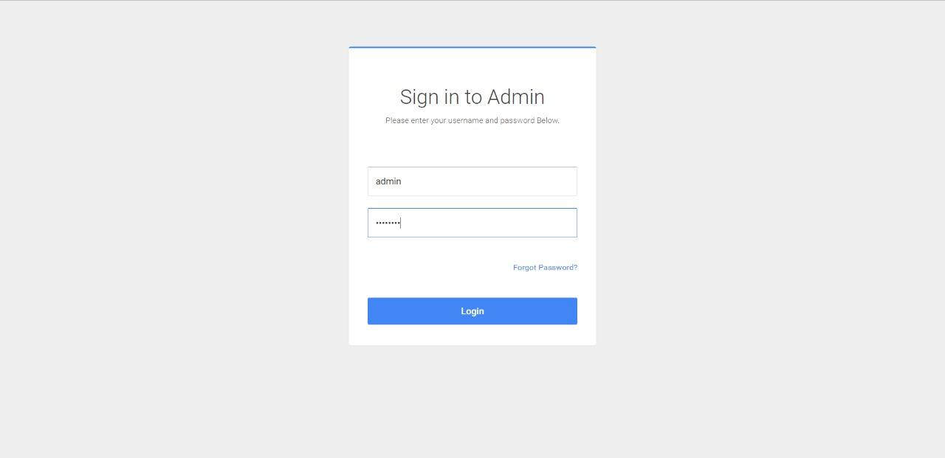

Fig 1:Admin Login page

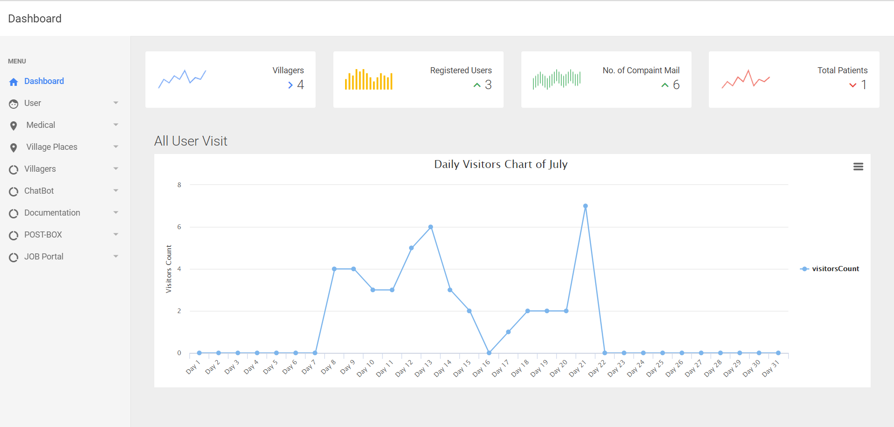

Fig 2: Dashboard

*CWIT,PUNE-1* *10* *DEPT OF COMPUTER ENGG*



*The Village*

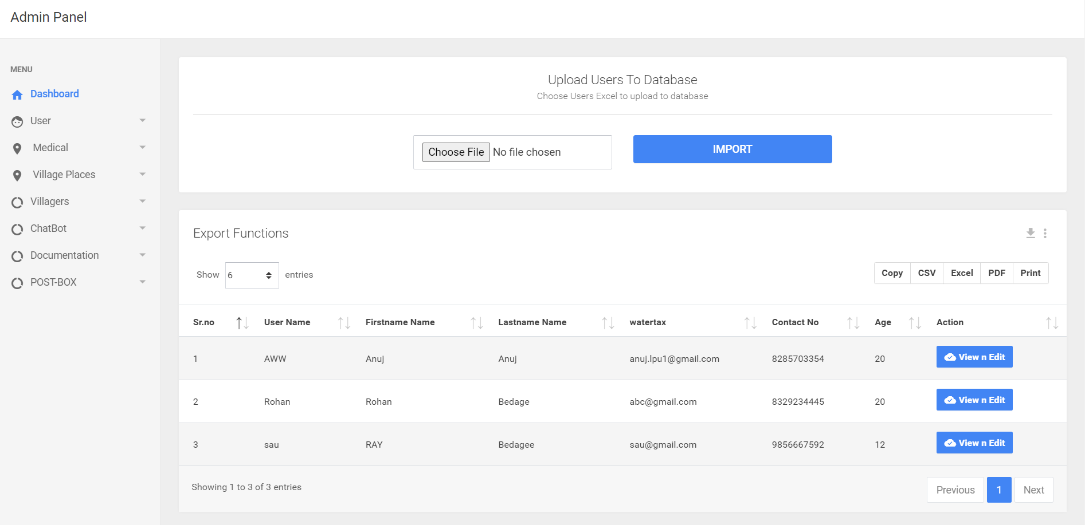

Fig 3: Users Table



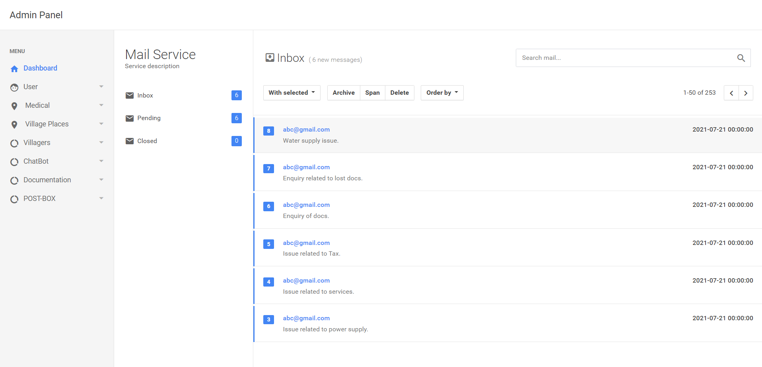

Fig 4: Contact Mail Support

*CWIT,PUNE-1* *11* *DEPT OF COMPUTER ENGG*



*The Village*

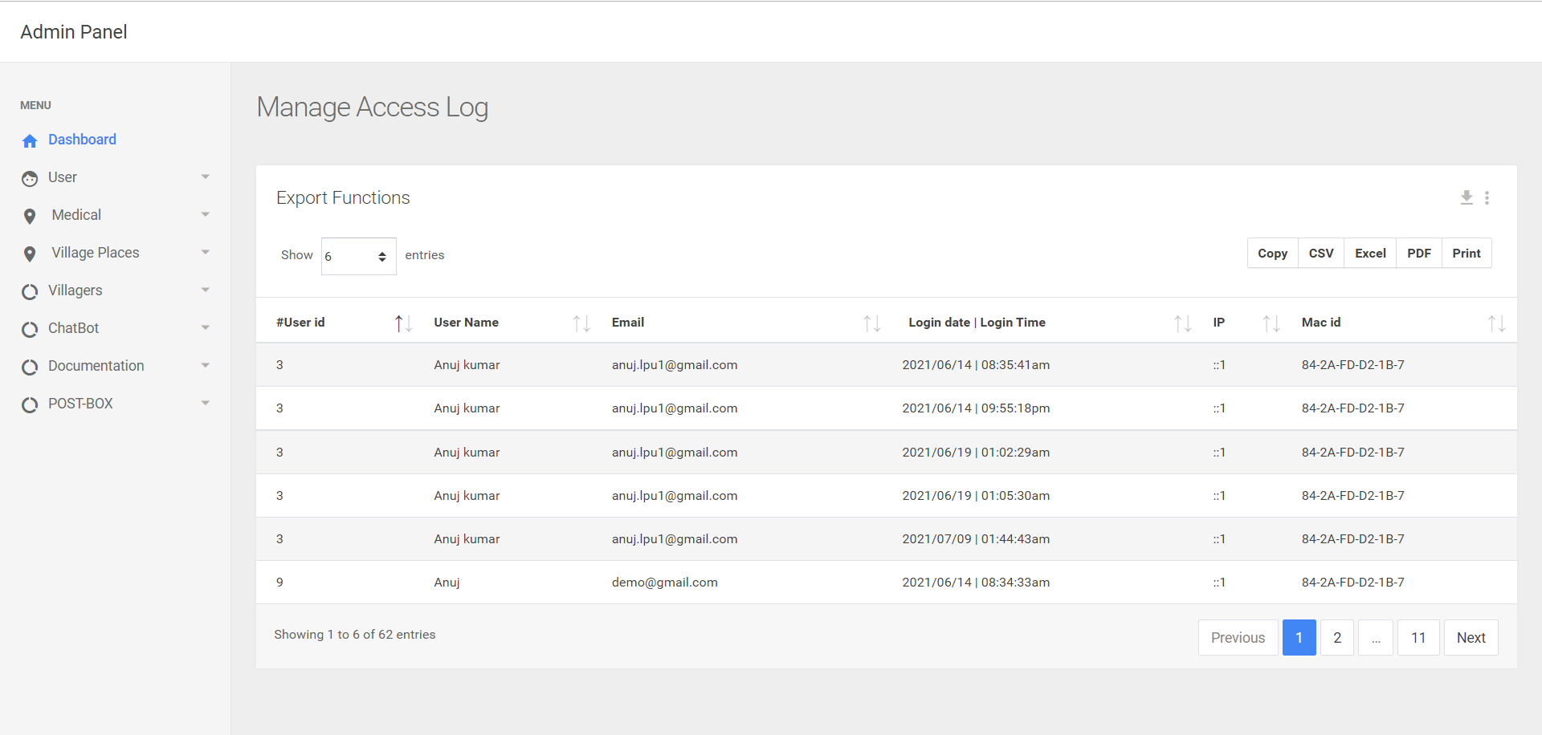

Fig 5: User Activity Log



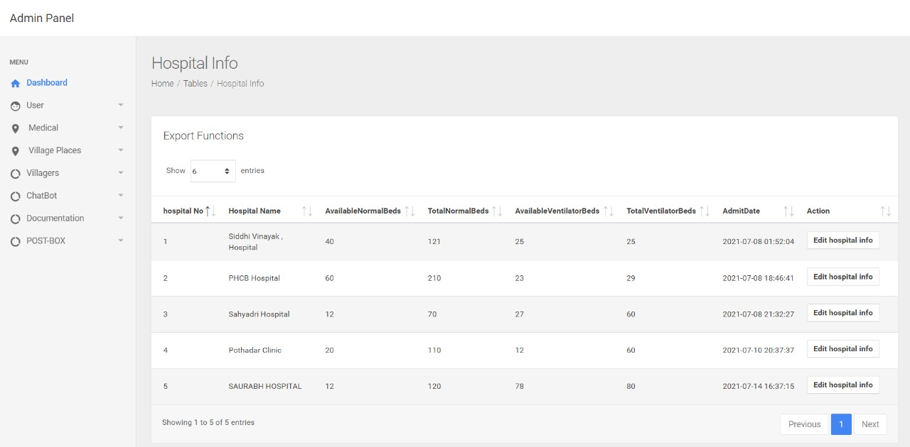

Fig 6: Hospital Info

*CWIT,PUNE-1* *12* *DEPT OF COMPUTER ENGG*



*The Village*



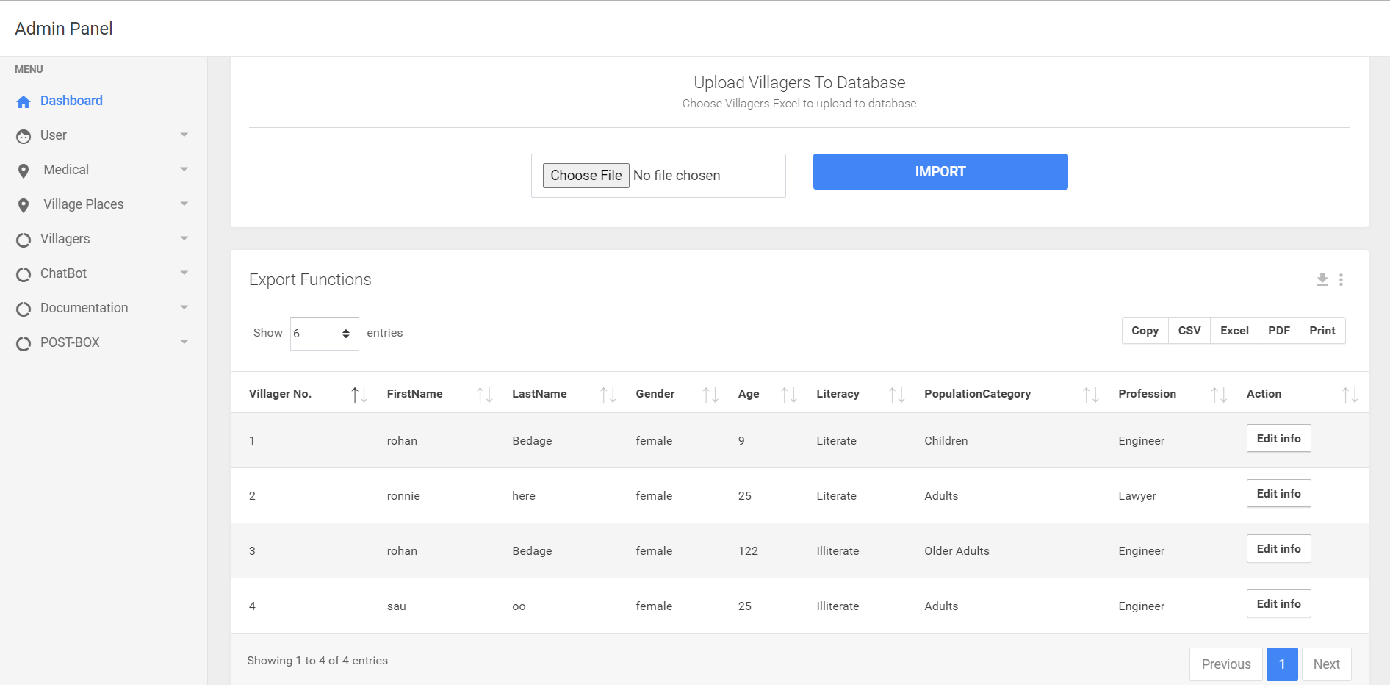

Fig 7: Villagers Database

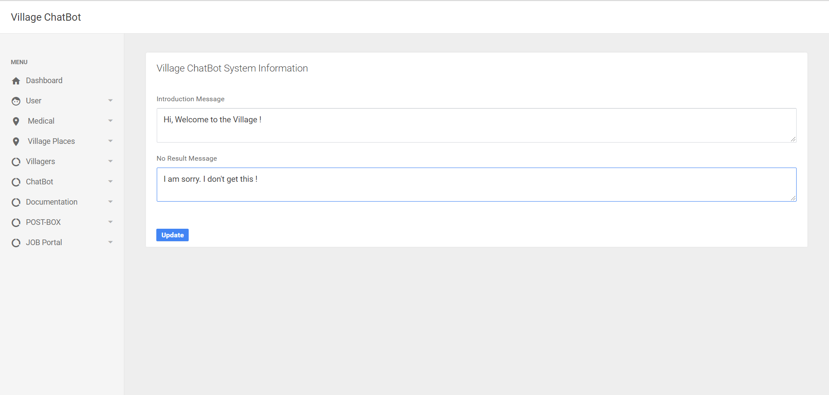

Fig 8: Village Chat-Bot

*CWIT,PUNE-1* *13* *DEPT OF COMPUTER ENGG*



*The Village*

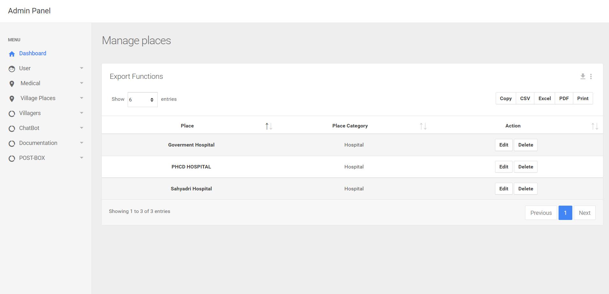

Fig 9: Places Management



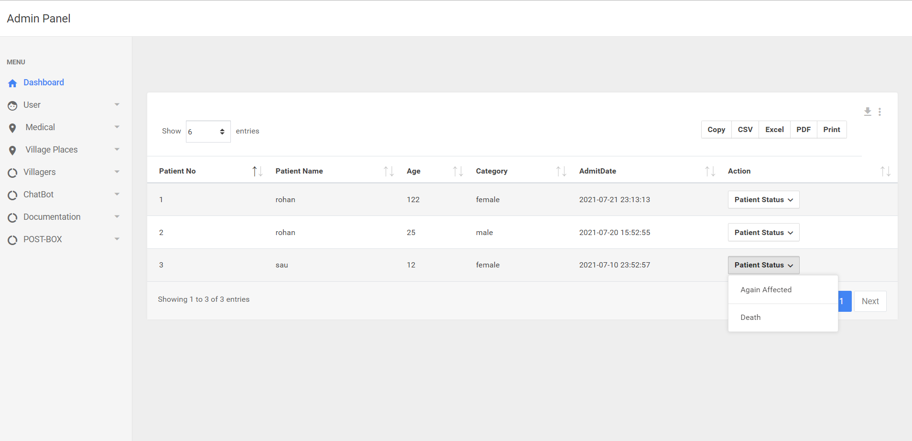

Fig 10: Patient Data

*CWIT,PUNE-1* *14* *DEPT OF COMPUTER ENGG*



*The Village*

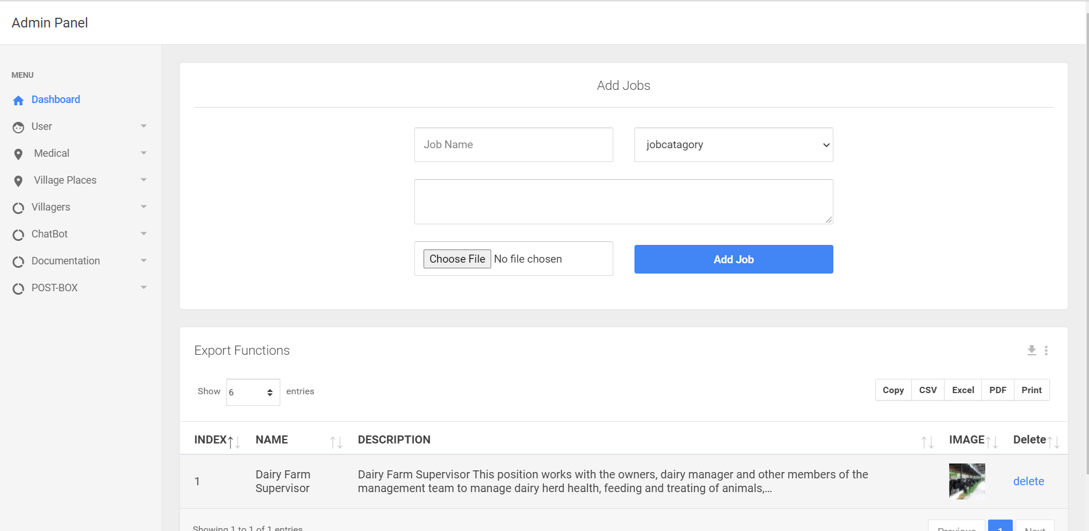

Fig 11: Add Jobs



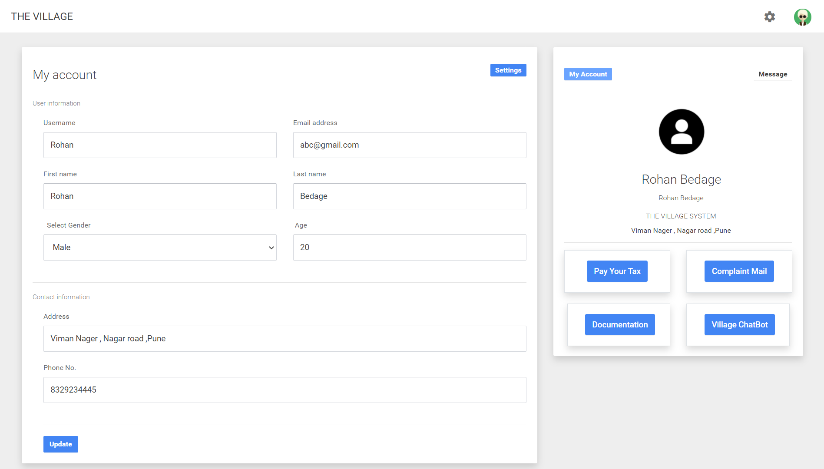

Fig 12: User Profile

*CWIT,PUNE-1* *15* *DEPT OF COMPUTER ENGG*



*The Village*

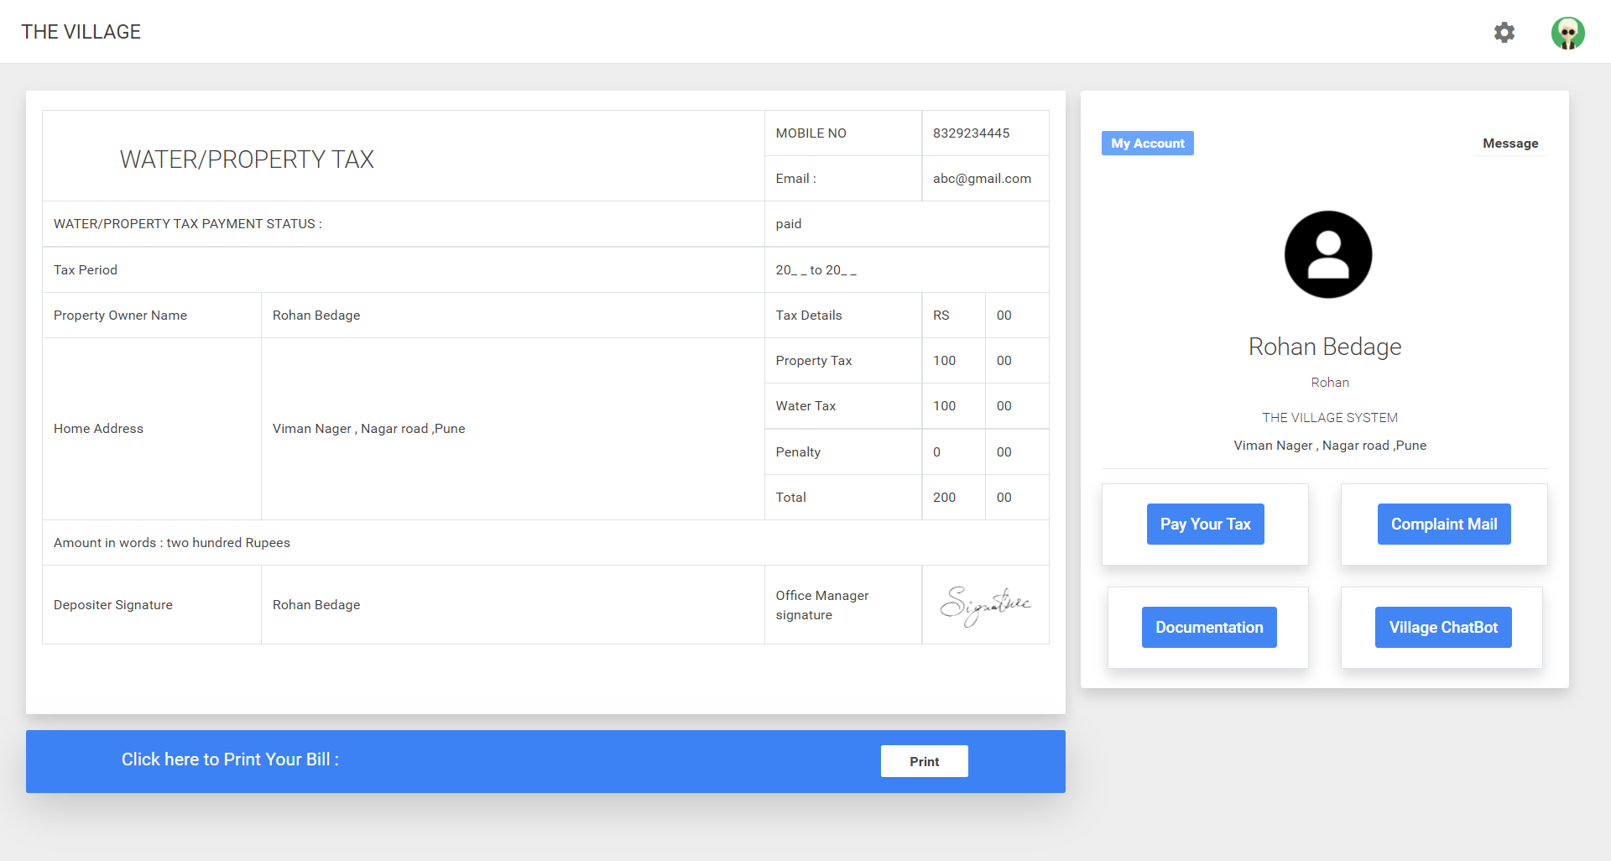

Fig 13: Online Tax Portal

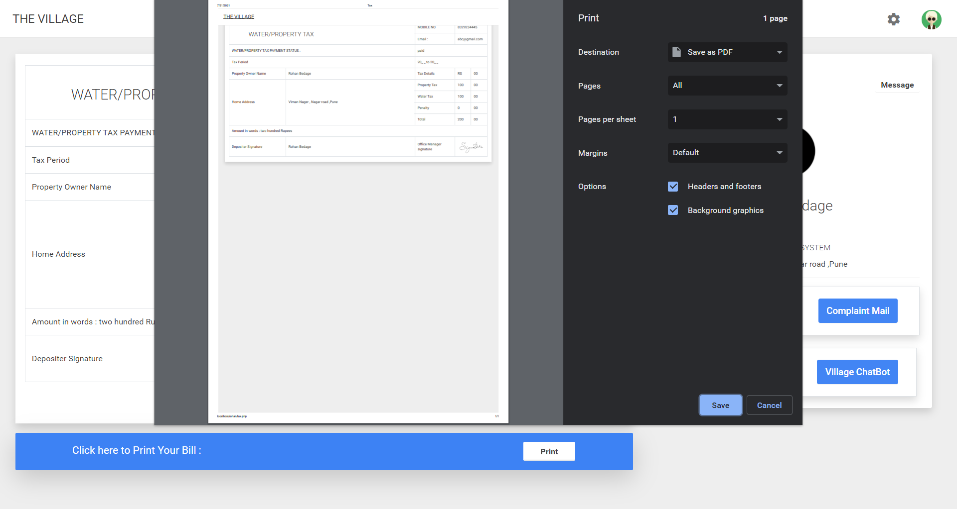

Fig 14: Printable Receipt Generation

*CWIT,PUNE-1* *16* *DEPT OF COMPUTER ENGG*



*The Village* 

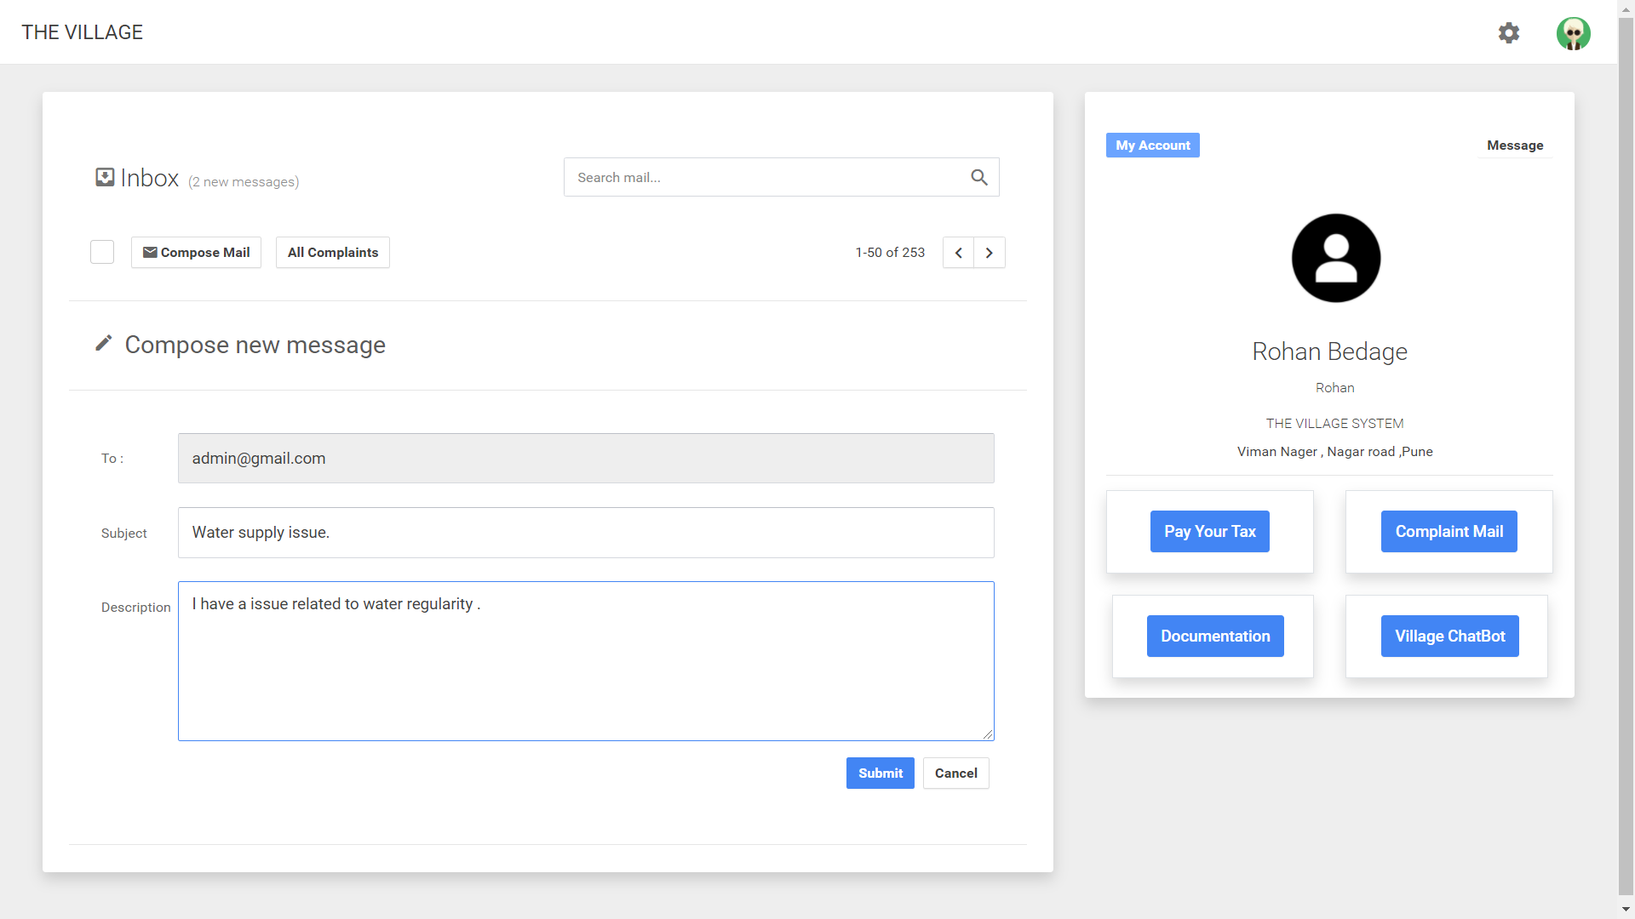

Fig 15: Complaint Box

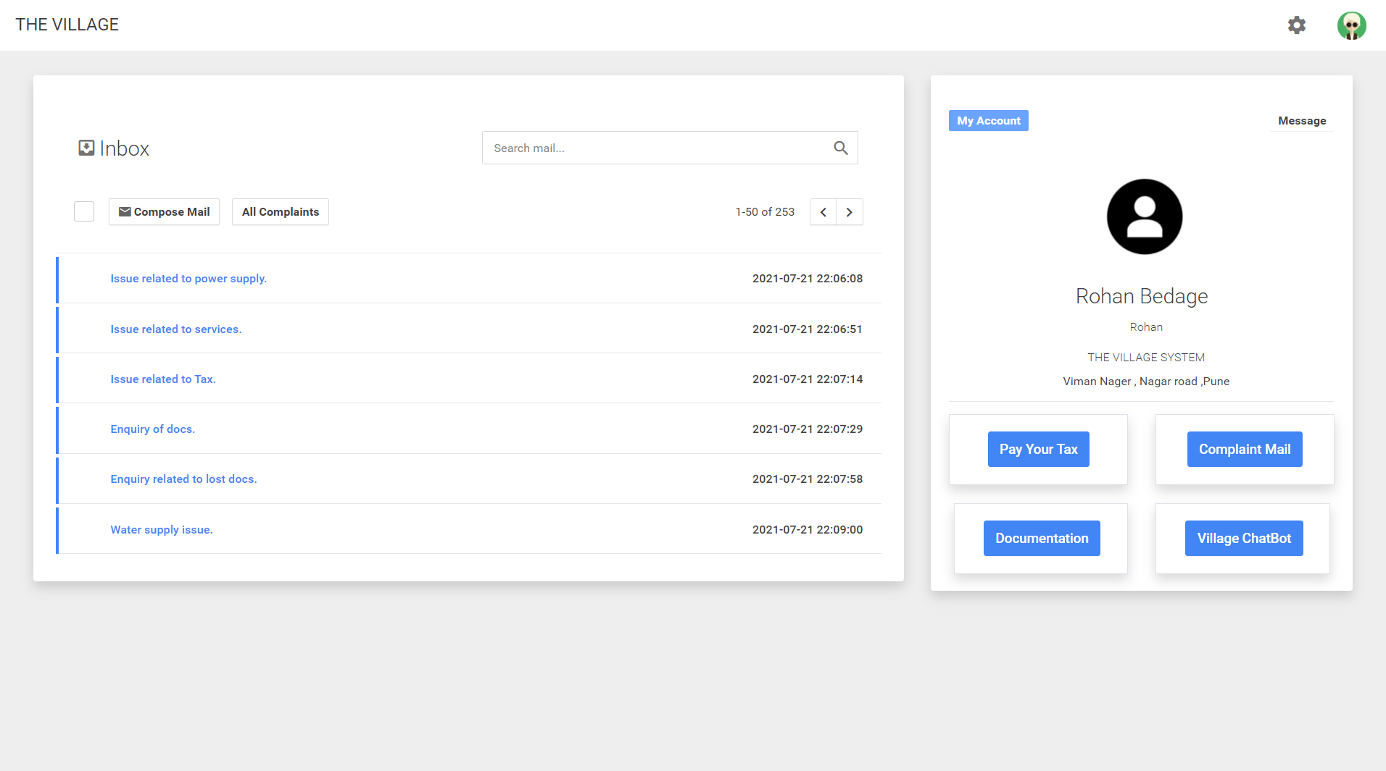

Fig 16: Inbox

*CWIT,PUNE-1* *17* *DEPT OF COMPUTER ENGG*



*The Village*

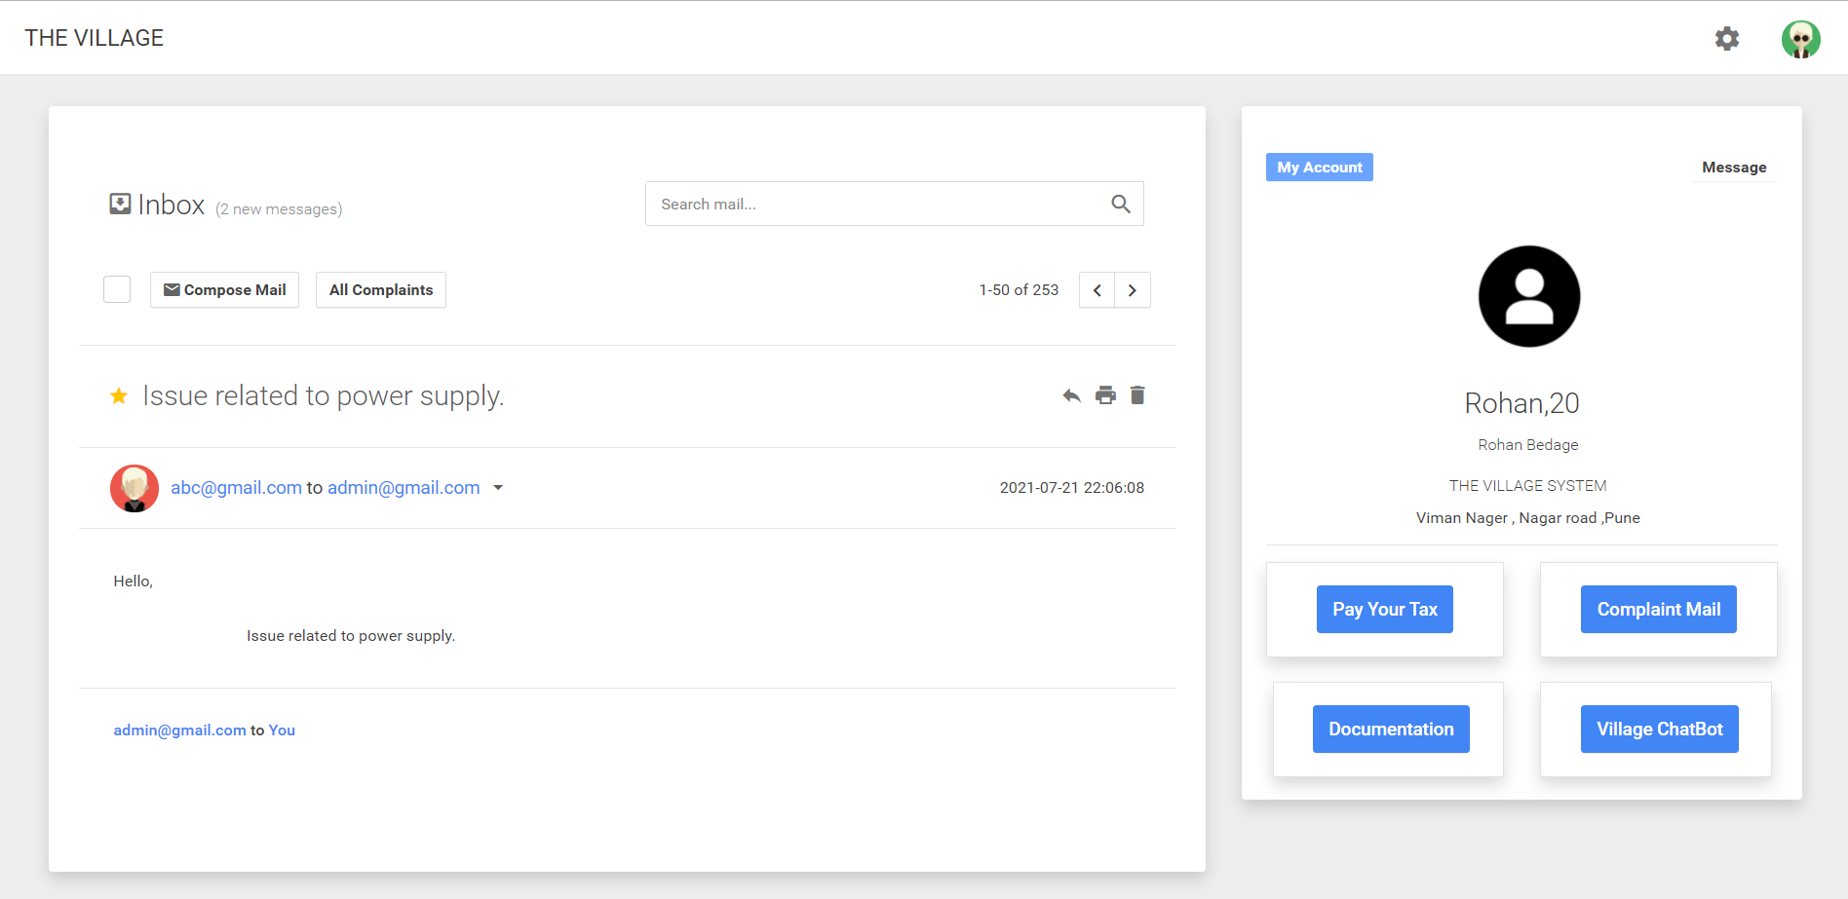

Fig 17: Complaint Details



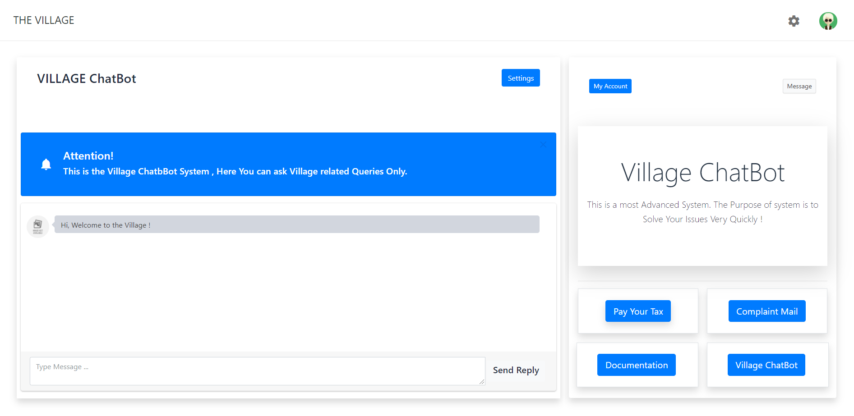

Fig 18: Village Chat-Bot

*CWIT,PUNE-1* *18* *DEPT OF COMPUTER ENGG*



*The Village*

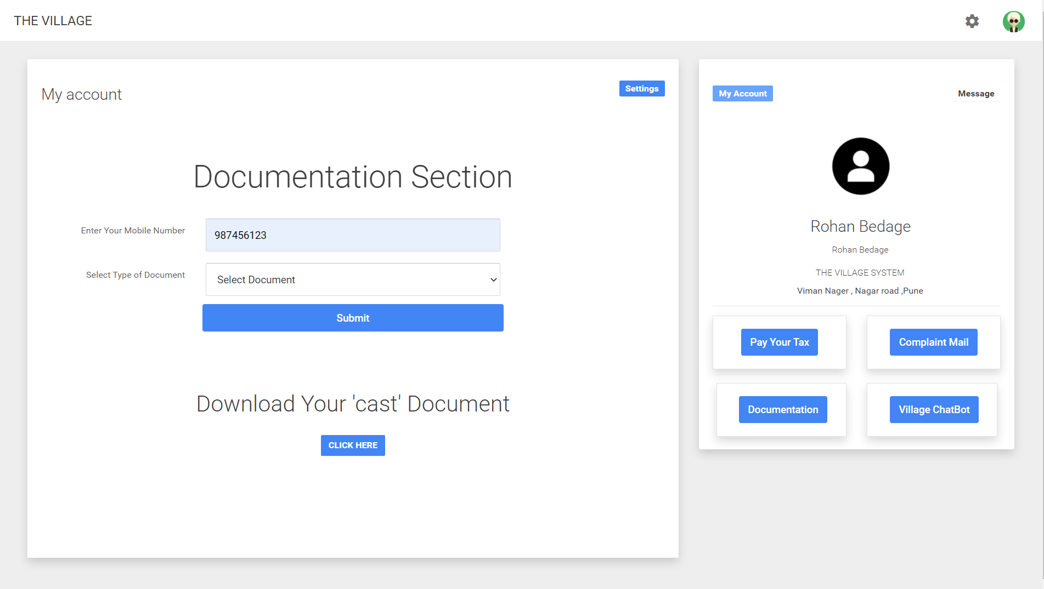

Fig 19: User Documents



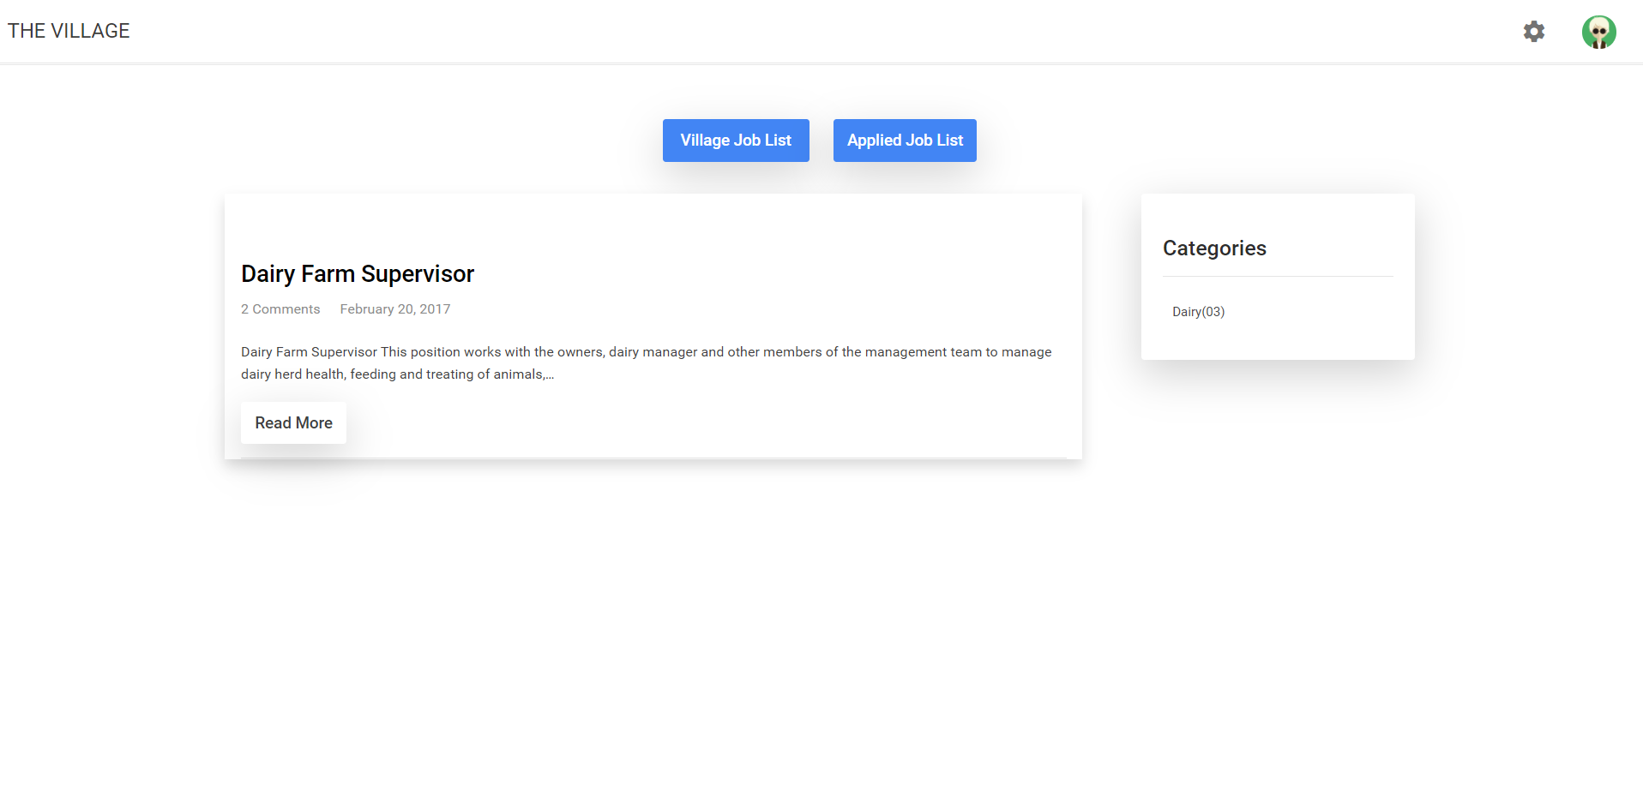

Fig 20: Job Portal

*CWIT,PUNE-1* *19* *DEPT OF COMPUTER ENGG*



*The Village*

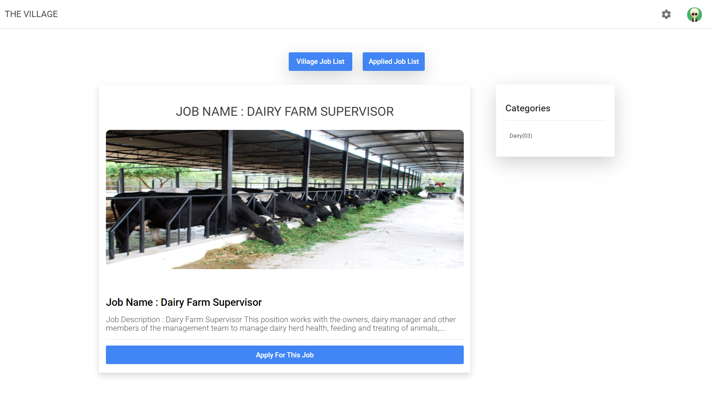

Fig 21: View Jobs



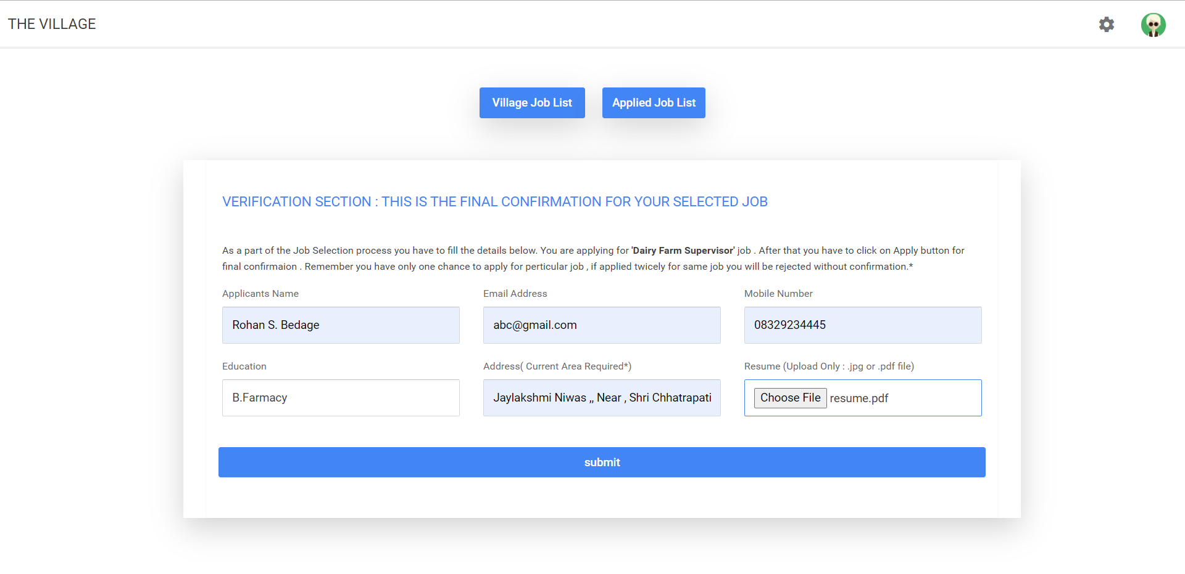

Fig 22:Apply Jobs

*CWIT,PUNE-1* *20* *DEPT OF COMPUTER ENGG*



*The Village*

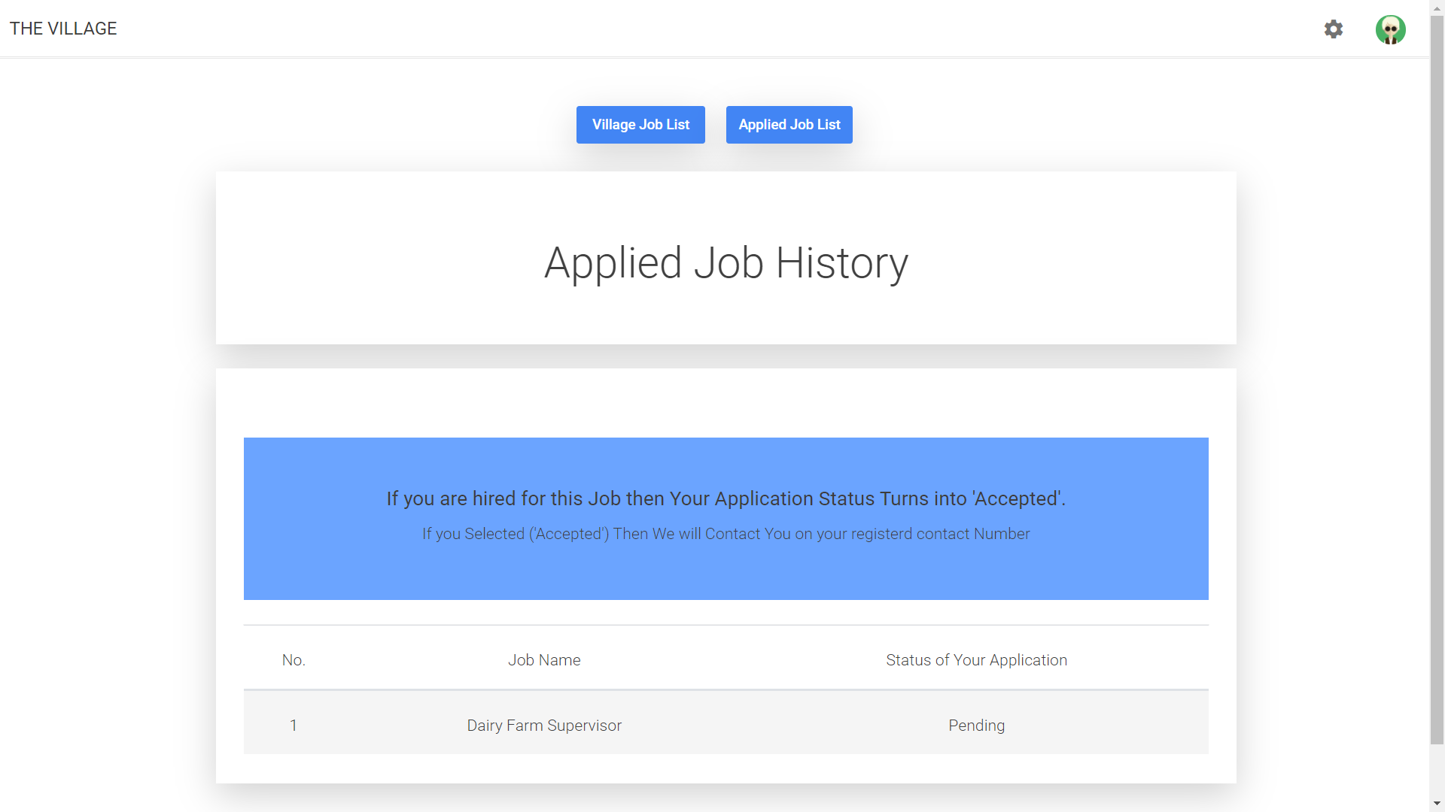

Fig 23: Job History

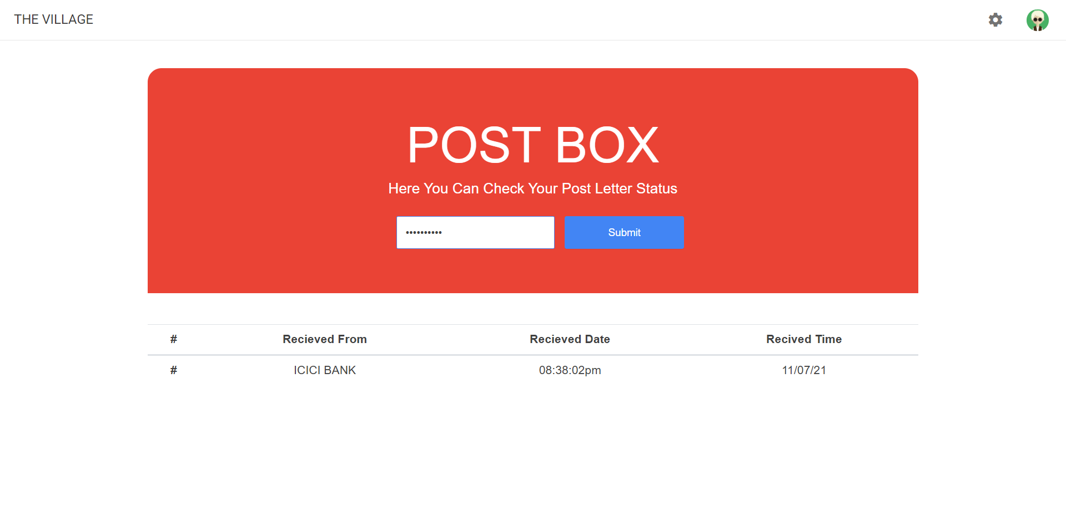

Fig 24: Post Box

*CWIT,PUNE-1* *21* *DEPT OF COMPUTER ENGG*



*The Village*



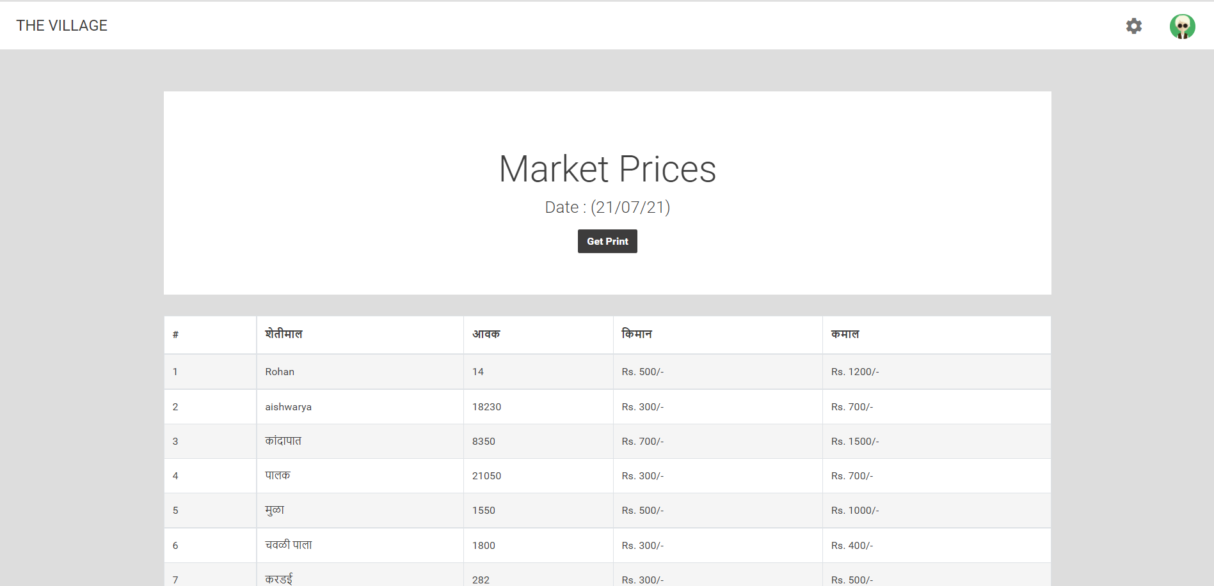

Fig 25: Market Prices

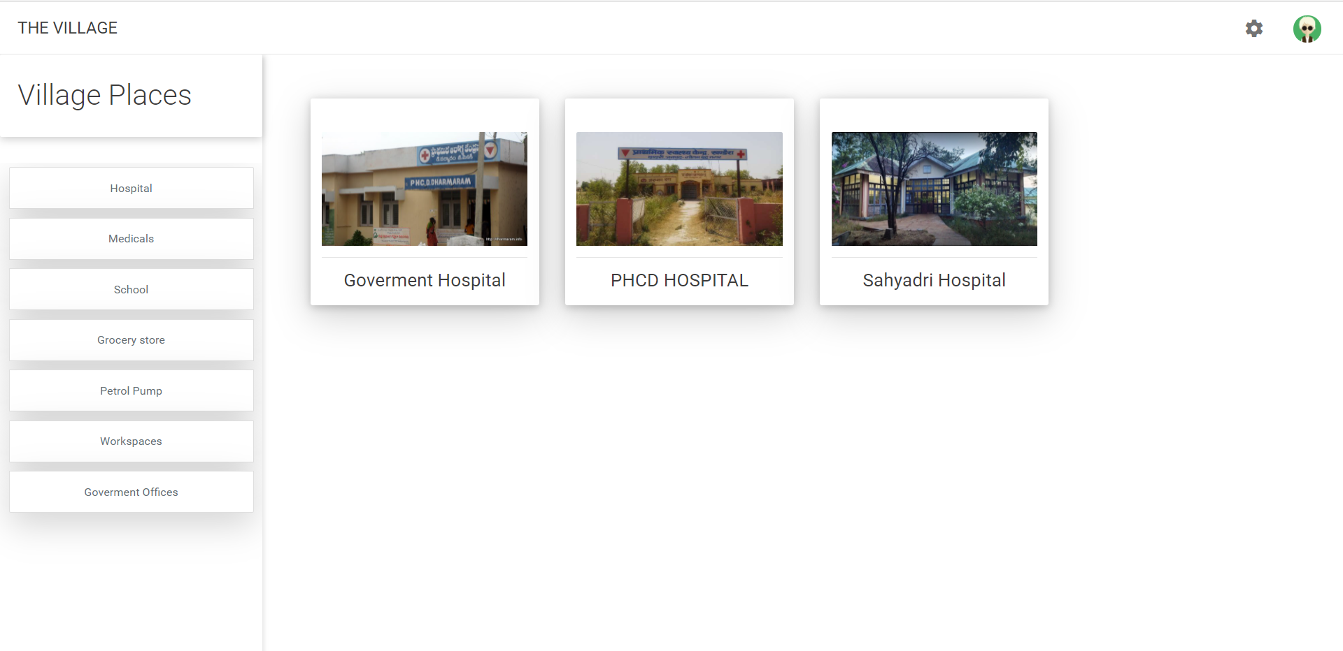

Fig 26: Village Places

*CWIT,PUNE-1* *22* *DEPT OF COMPUTER ENGG*



*The Village*



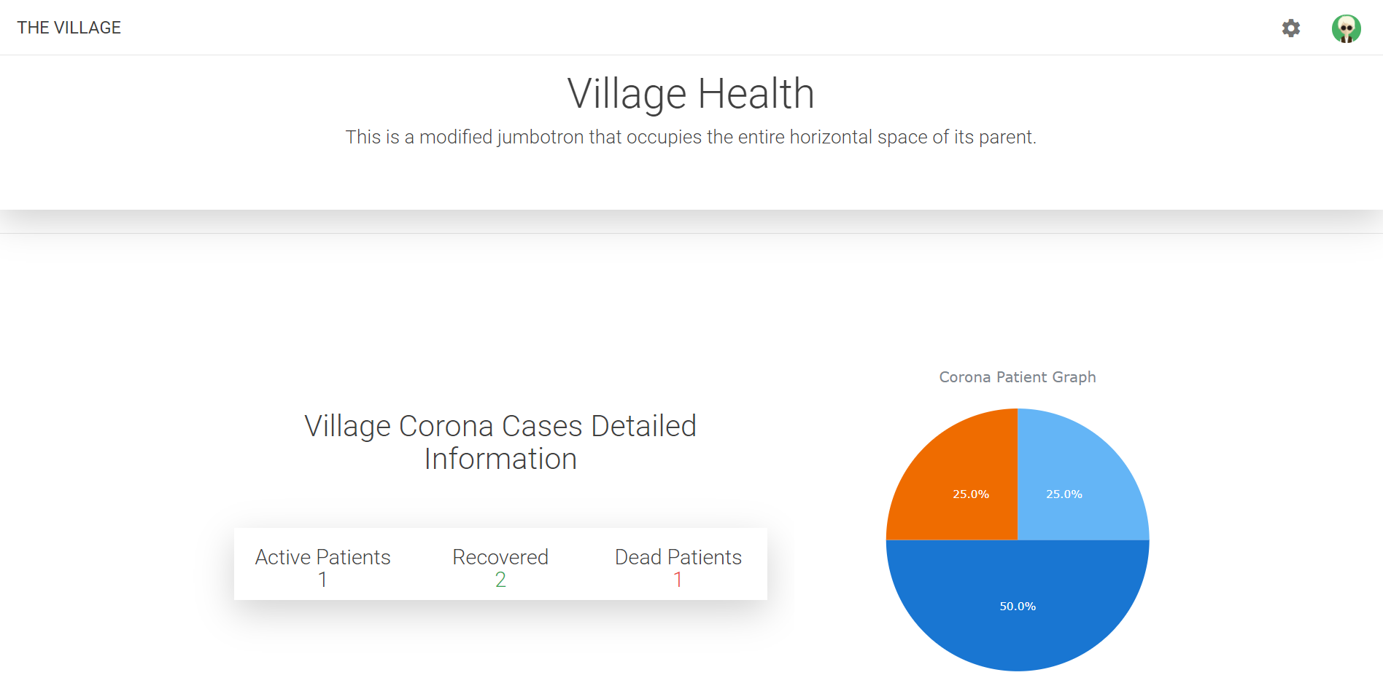

Fig 27: Village Health

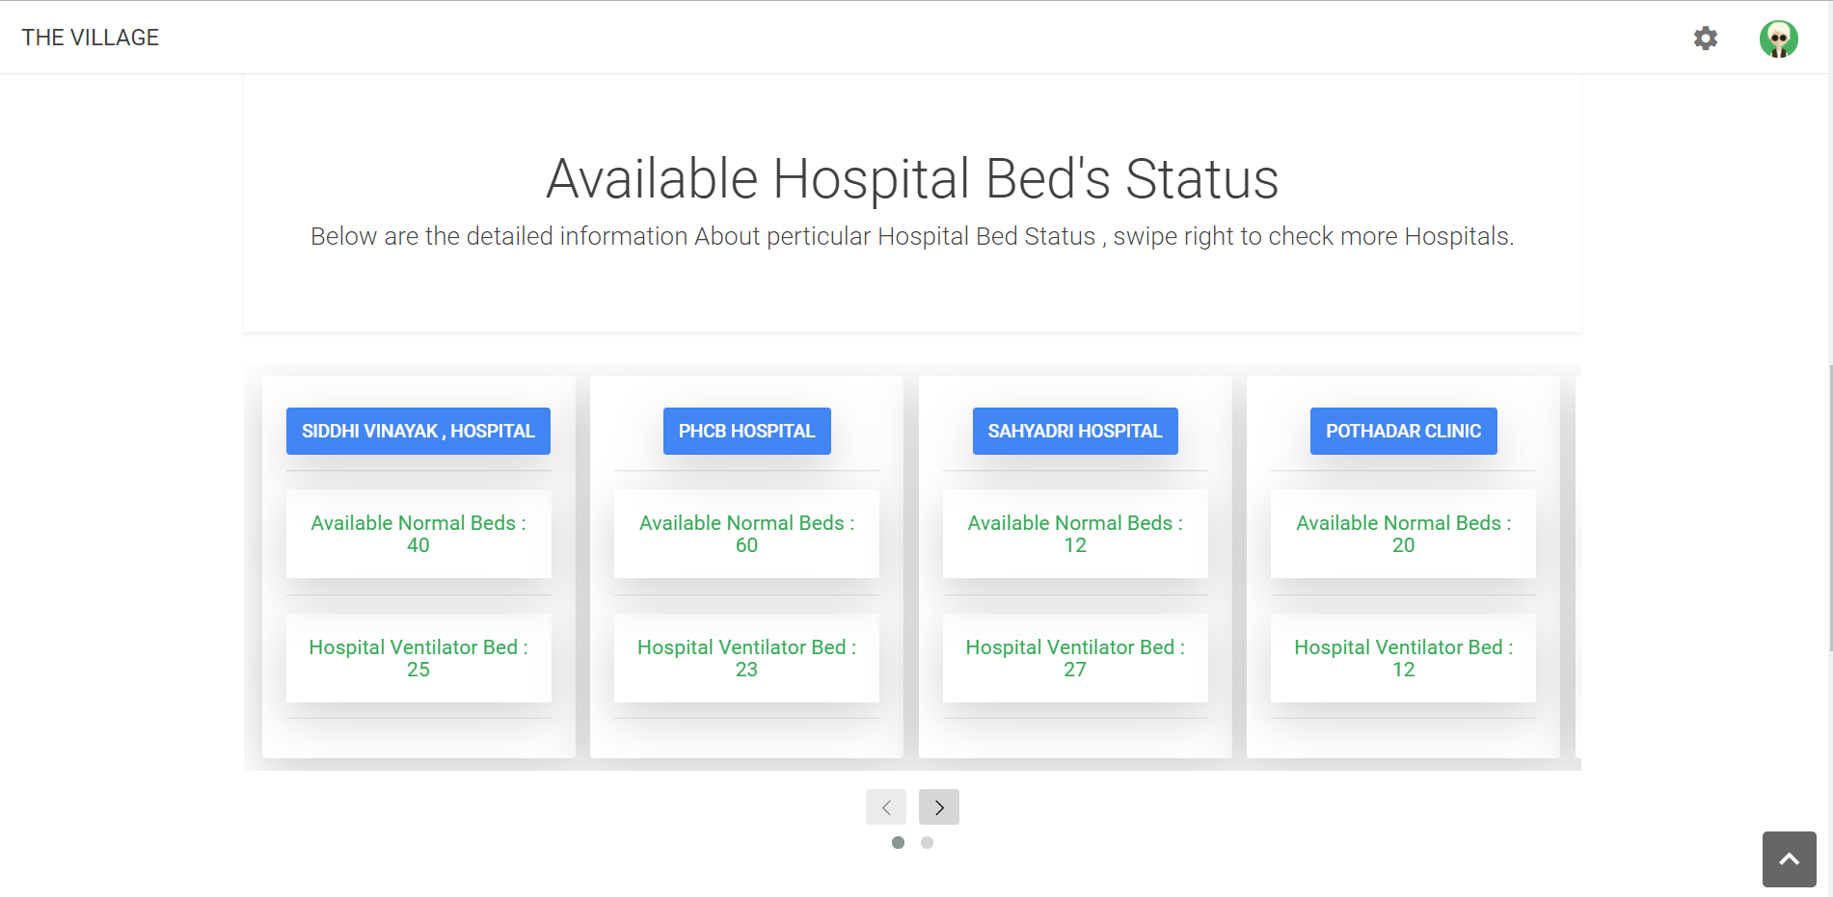

Fig 28: Available Beds

*CWIT,PUNE-1* *23* *DEPT OF COMPUTER ENGG*



*The Village*



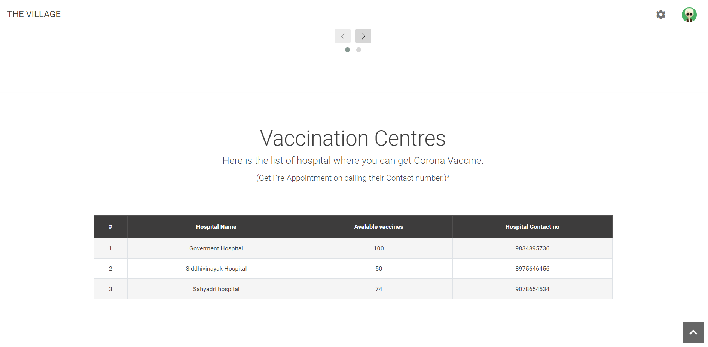

Fig 29: Available Vaccine centre

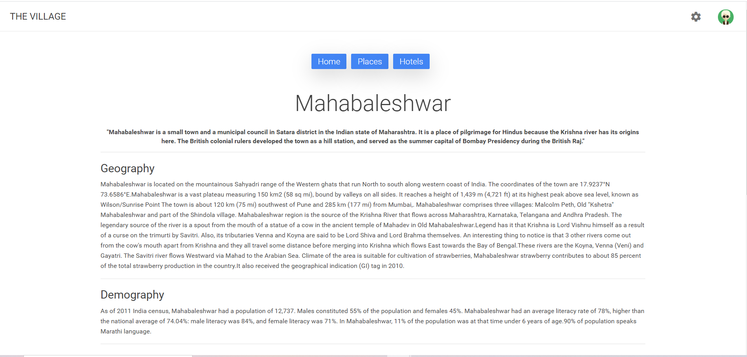

Fig 30: Tourist Places

*CWIT,PUNE-1* *24* *DEPT OF COMPUTER ENGG*



*The Village*

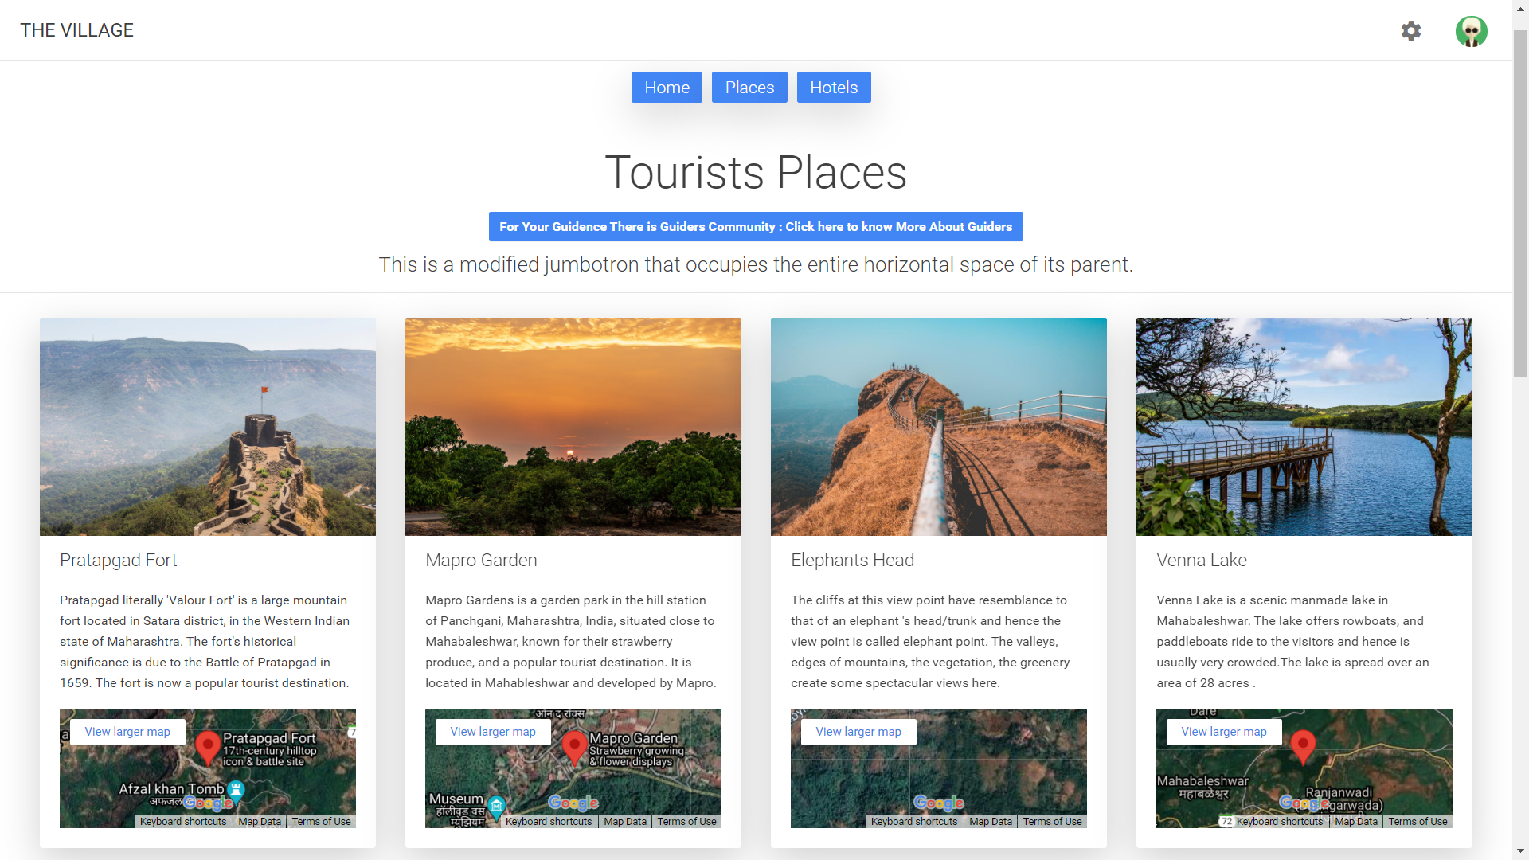

Fig 31: Tourist Places

*CWIT,PUNE-1* *25* *DEPT OF COMPUTER ENGG*



*The Village*

**9. Future Prospect :**

The future prospect of the Project is to support techno economic viability of digital technology, projects for productive applications in village area livelihoods; standardize the technology packages for future applications; create awareness and capacity building activities on Information Technology systems.

This project aims that all citizens of India have payment systems that are online or cashless. Moreover, citizens are digitally literate, and digital resources are available in Indian languages. It will enable the public sector or government bodies to be digitally active, and thus citizens can download their government documents.

Under this project, certain villages will be transformed into digitally active, cashless villages, allowing rural residents to conduct most of their daily activities entirely online. The primary goal of the Digital Village initiative is to make towns more digitally engaged. Under this plan, the work of many rural institutes may be handled entirely via the internet; every rural resident would become digitally literate.

*CWIT,PUNE-1* *26* *DEPT OF COMPUTER ENGG*



*The Village*

**10. References**

**Links:**

1. <https://www.wikipedia.org/>
2. <https://stackoverflow.com/>
3. <https://www.w3schools.com/>
4. <https://www.geeksforgeeks.org/>
5. [India .All states, Districts,Villages,Schools,Colleges,Maps,Pin Codes of India (onefivenine.com)](http://www.onefivenine.com/)

*CWIT,PUNE-1* *27* *DEPT OF COMPUTER ENGG*

*CWIT,PUNE-1* *25* *DEPT OF COMPUTER ENGG*

